Web Programming Lab MIDTERM Assignment Report 2016312761 여혁수

1. The design or structure of your homepage should be match with your topic.

I made computer estimating commercial site. My homepage is composed of login page and signup page and 2 main pages. One main page shows piece products of computer. Another shows recommending finished products.

2. Make more than 3 html files, and the three html files should be able to move meaningfully to each other with links.

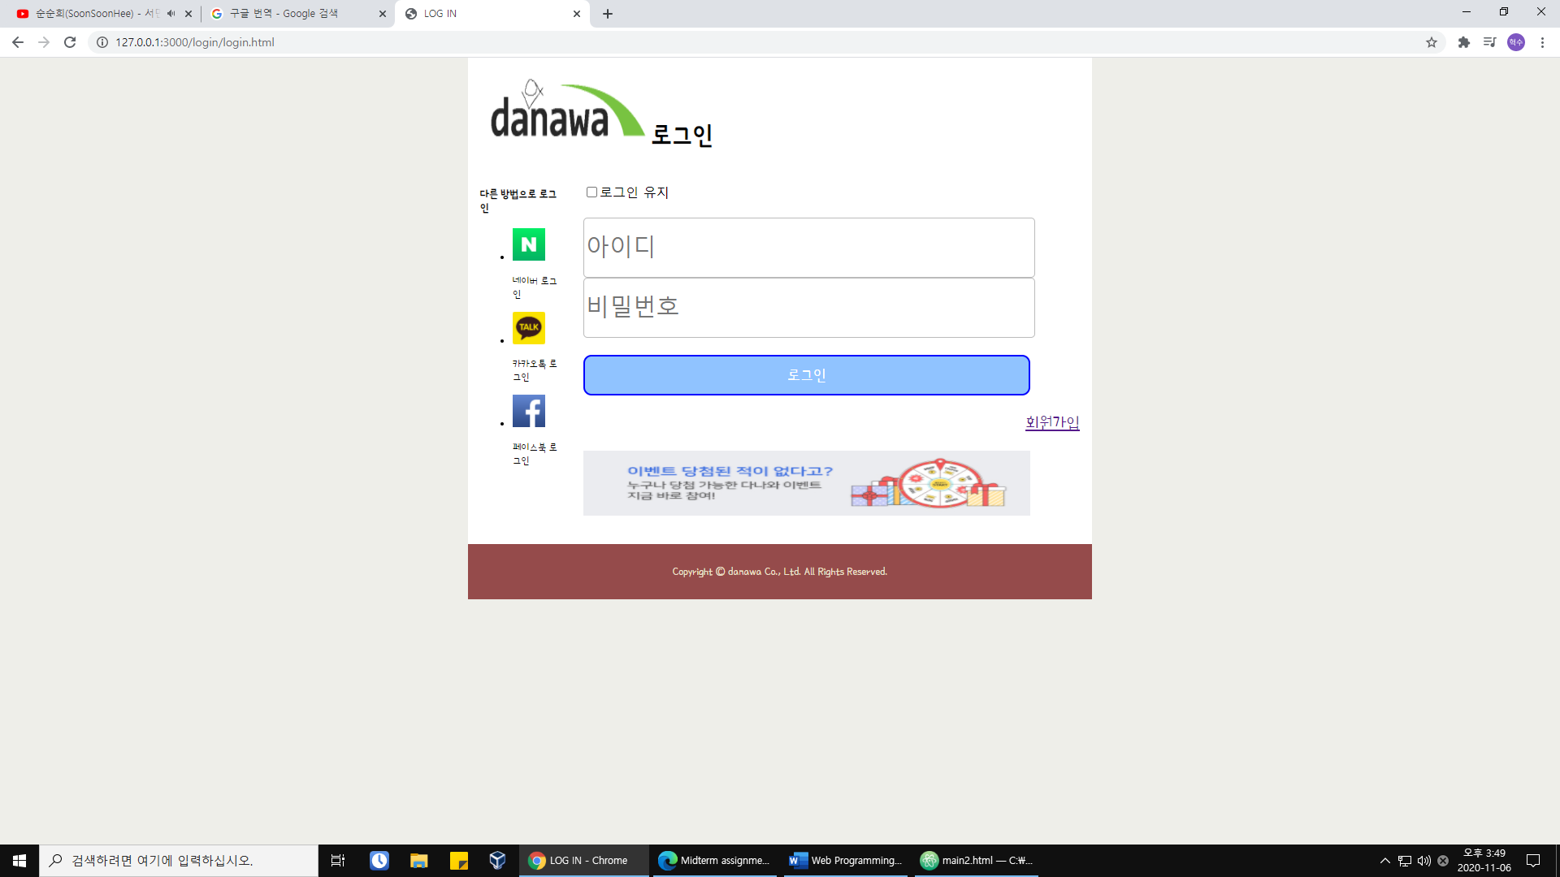main.html

Signup.html

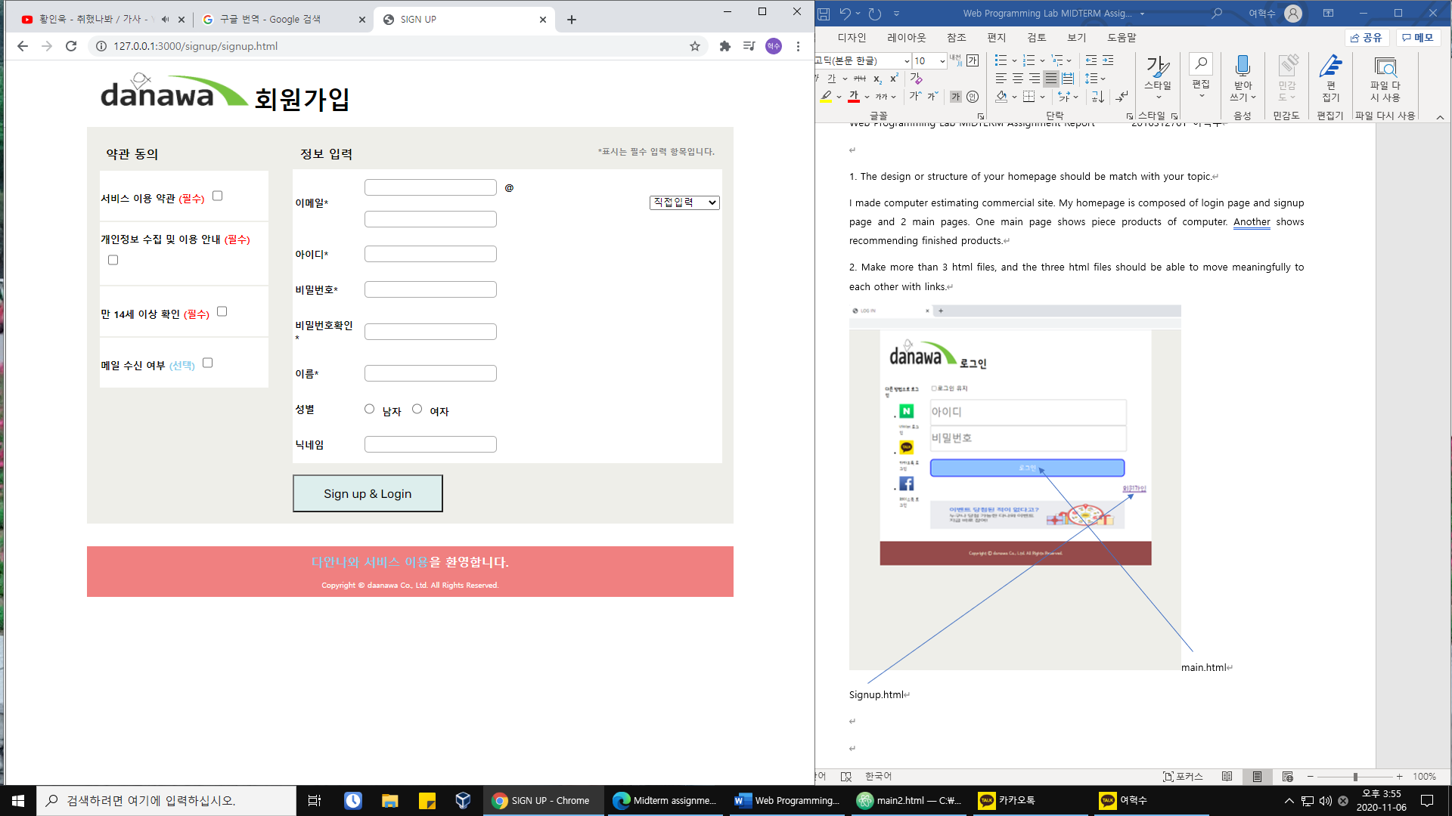main.html

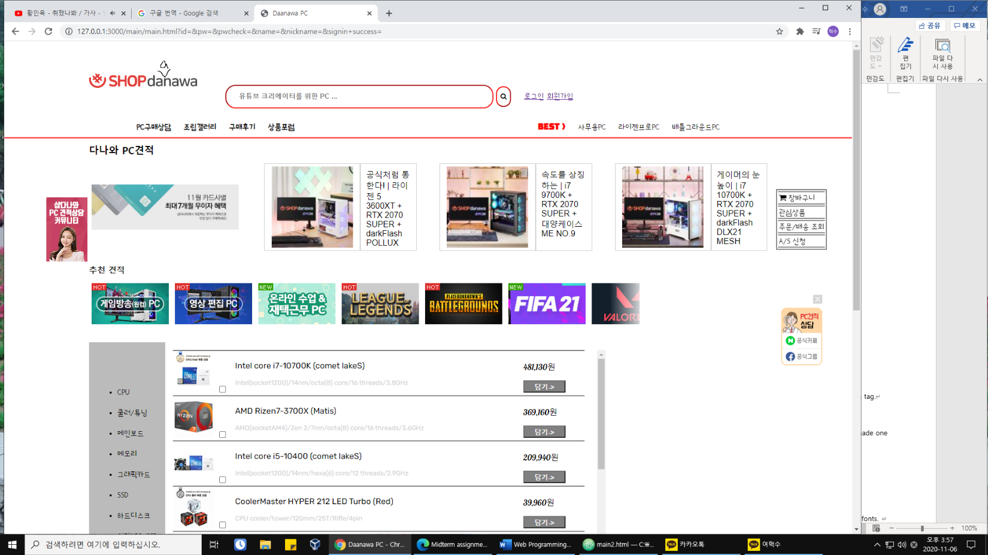

Login.html signup.html main2.html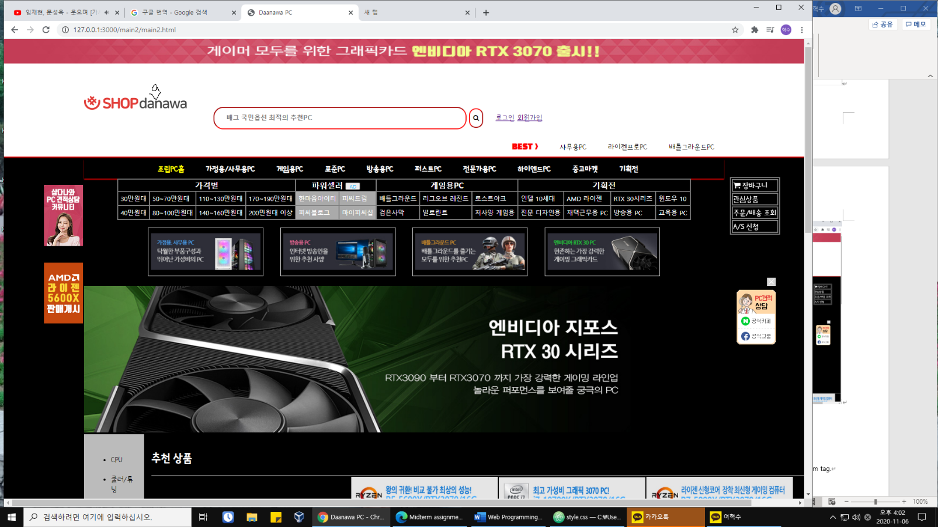

main.html login.html signup.html

3. Keep the basic form header, nav, content, footer.

ex) main2.html

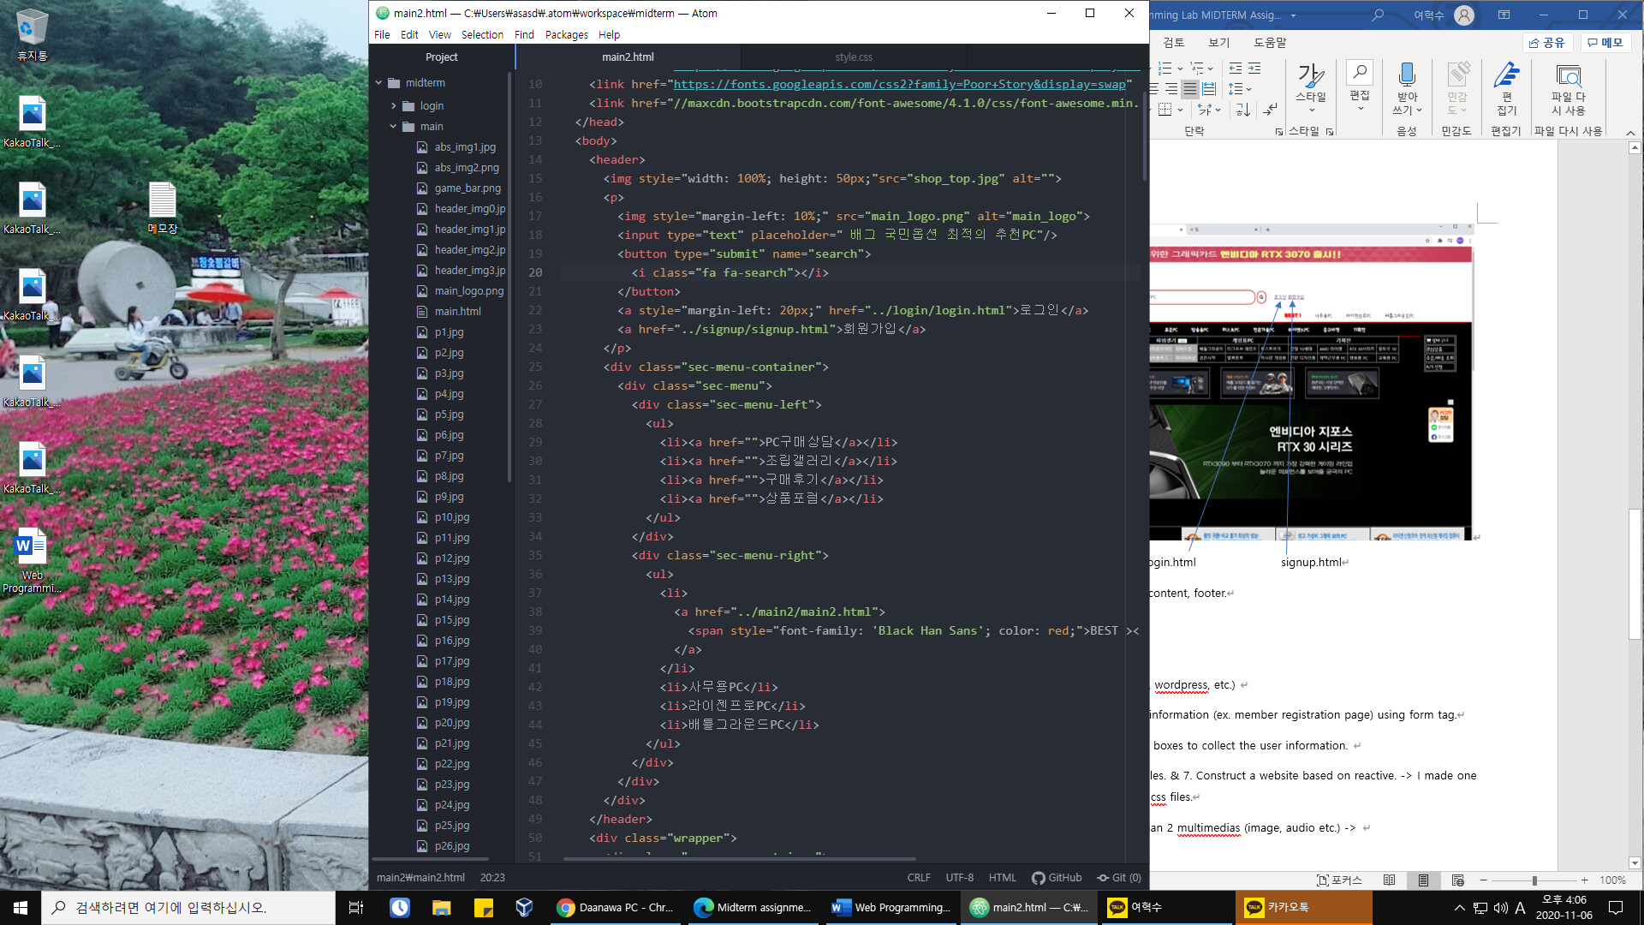

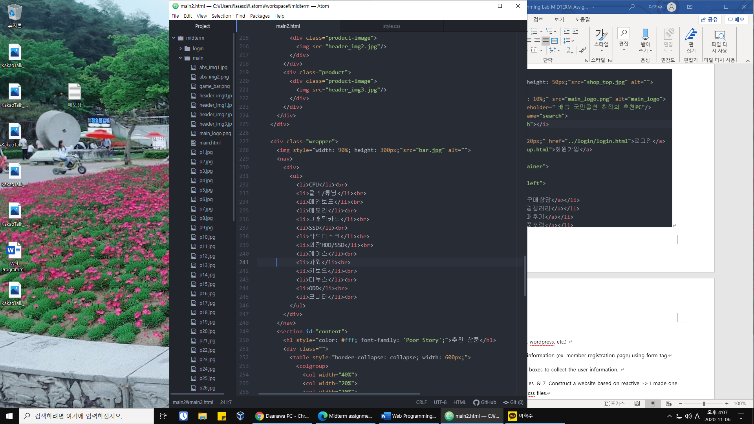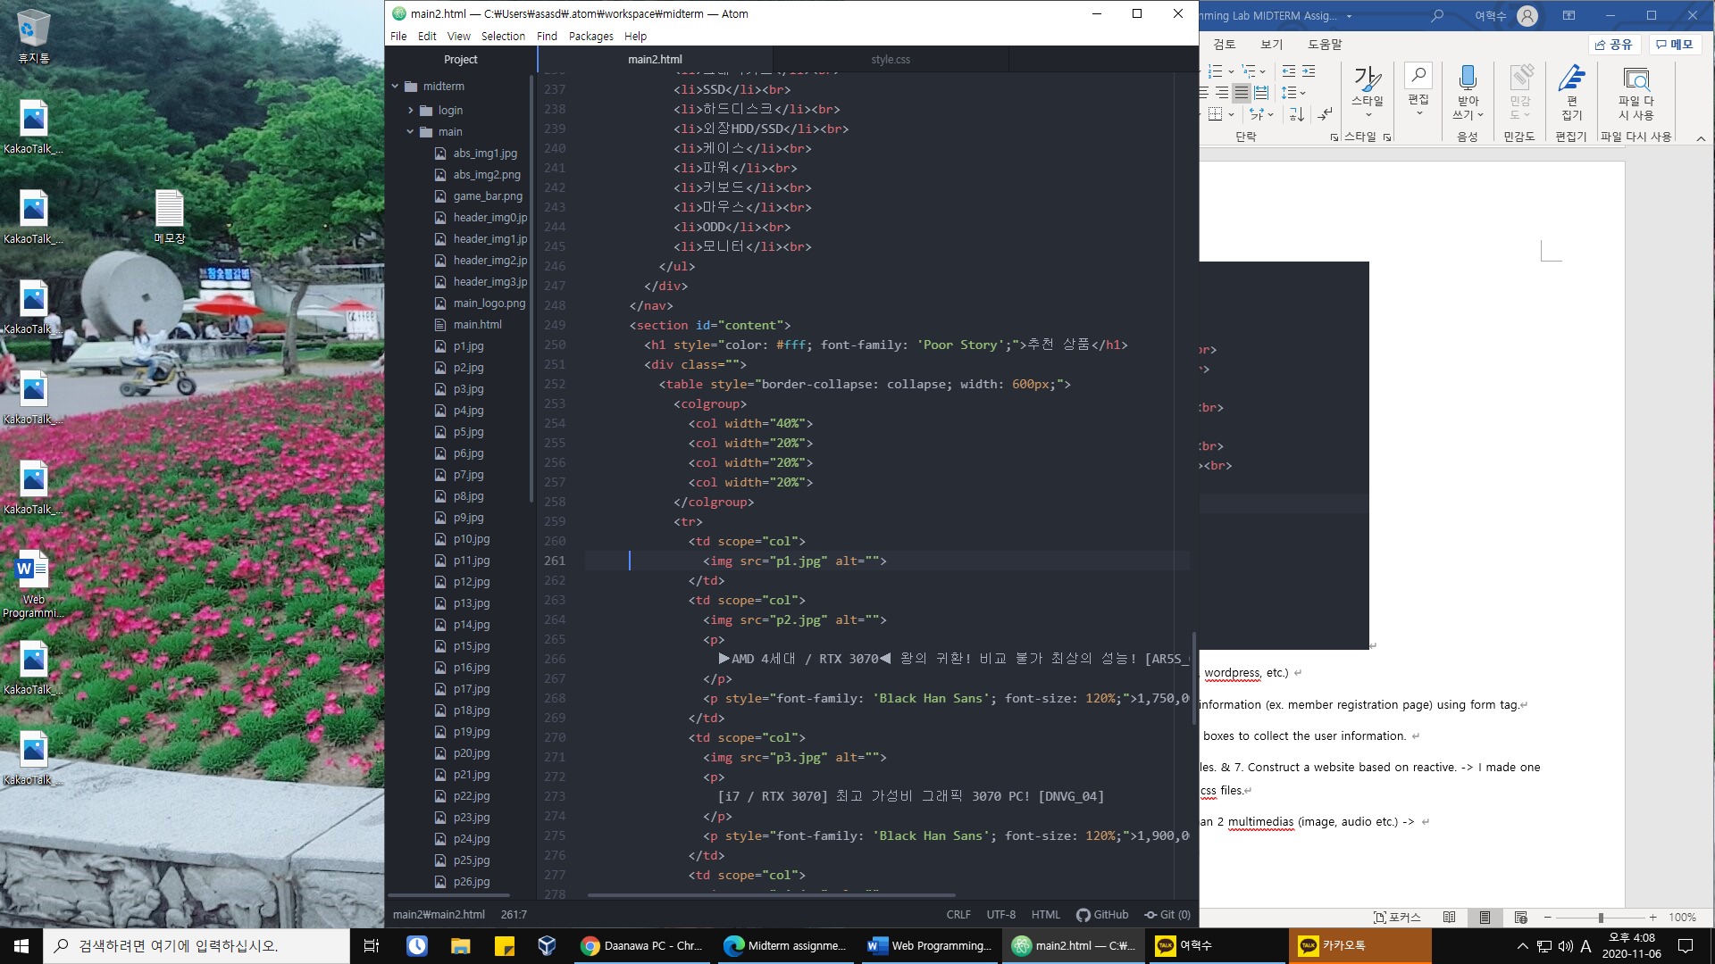

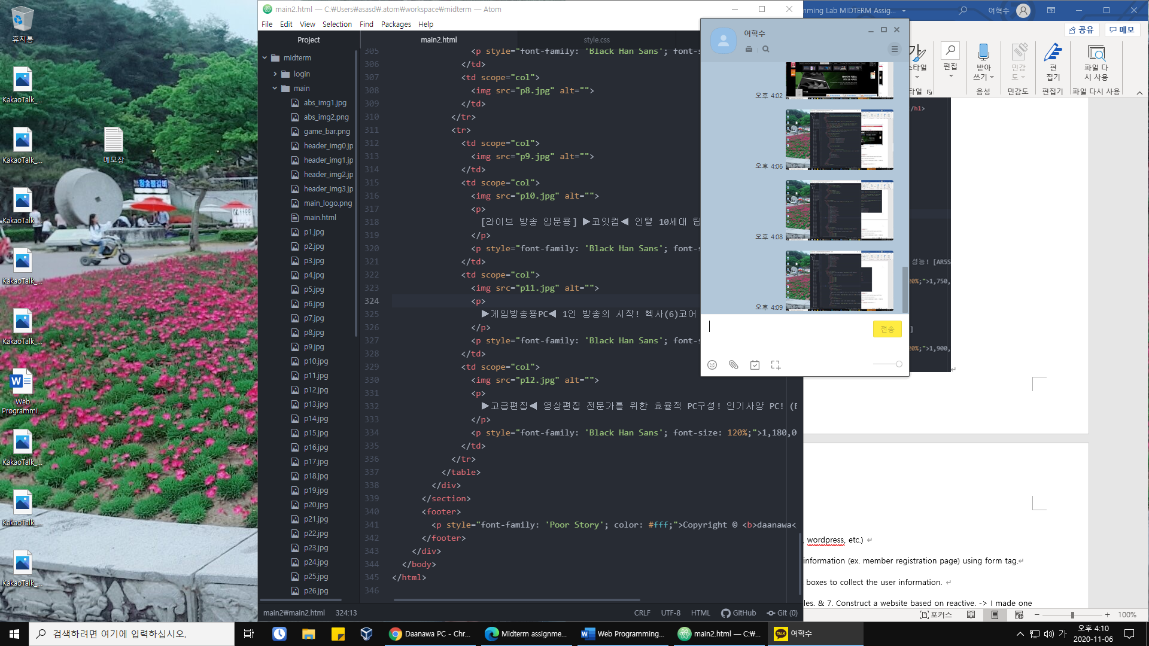

All html files are coded similar to these forms.

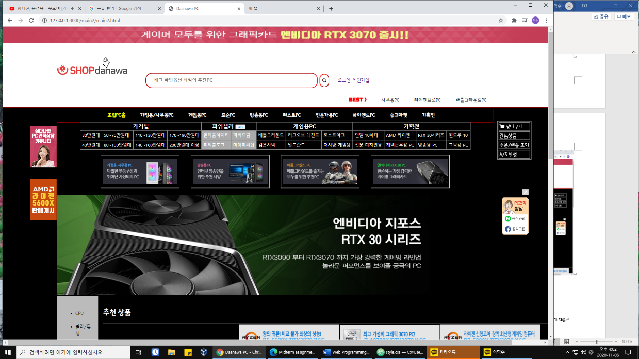

<header>

<nav> <section id=”content”>

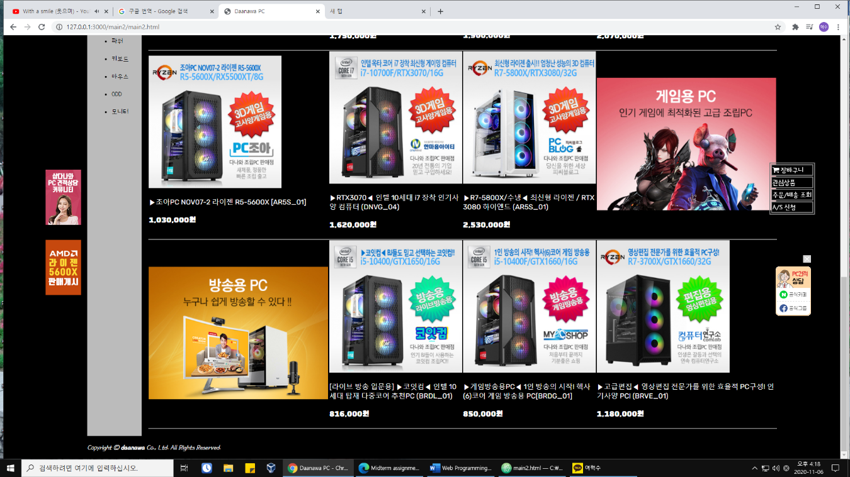content

<footer>

This is snapshot of main2.html.

4. Do not use frameworks.(boostrap, wordpress, etc.)

I do not use these.

5. Make the page that collects user information (ex. member registration page) using form tag.

▪ Use some radio boxes and check boxes to collect the user information.

Signup.html file is member registration page.

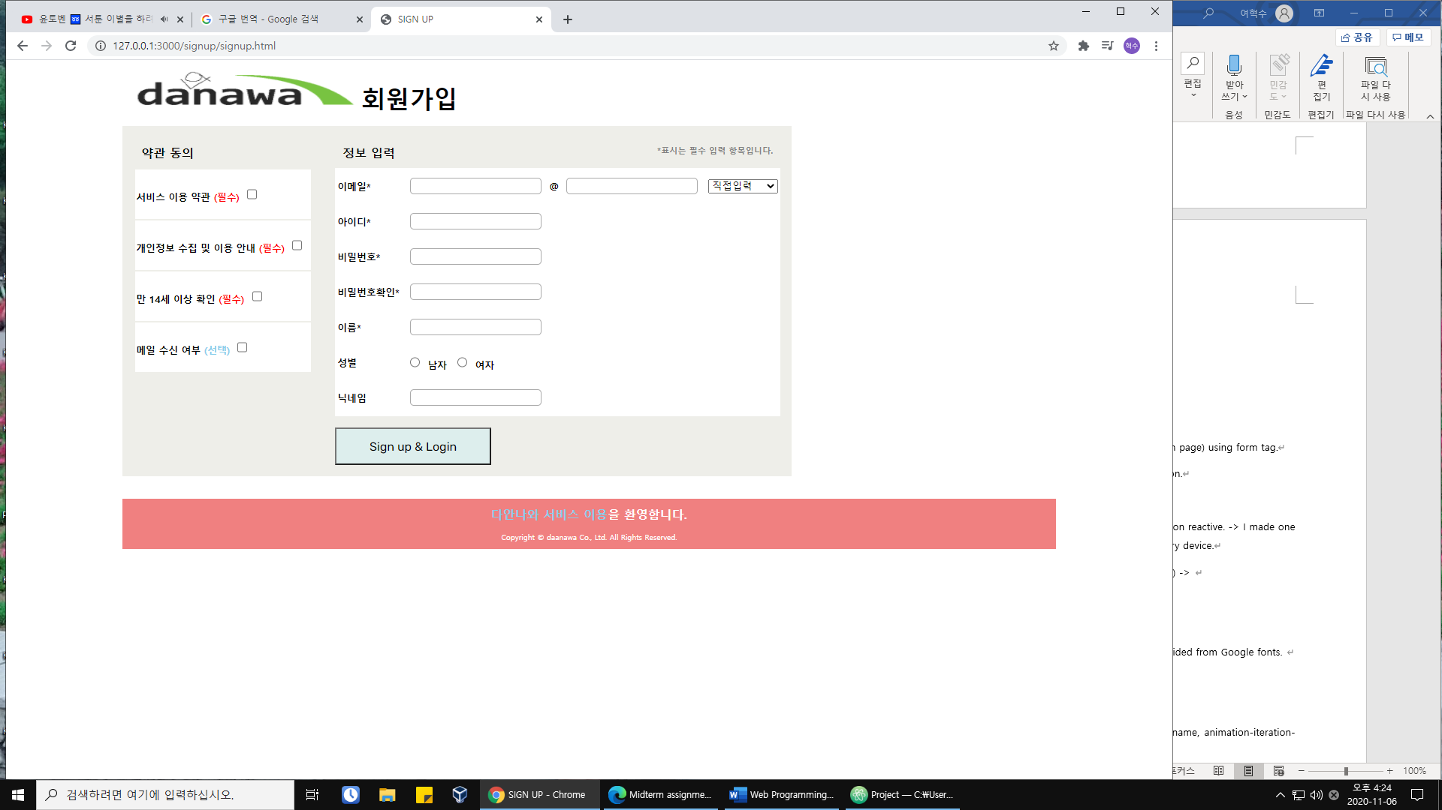

You can see checkboxes on the left side and also radio boxes to select gender.

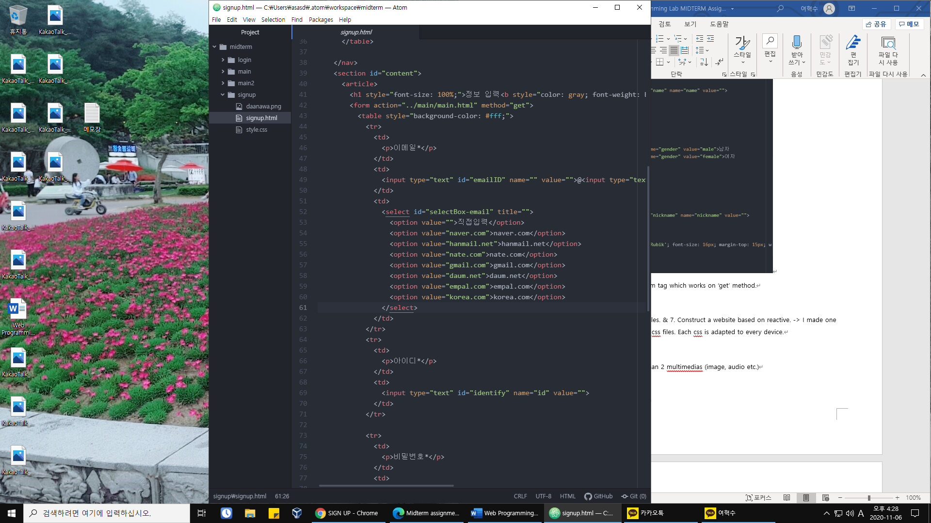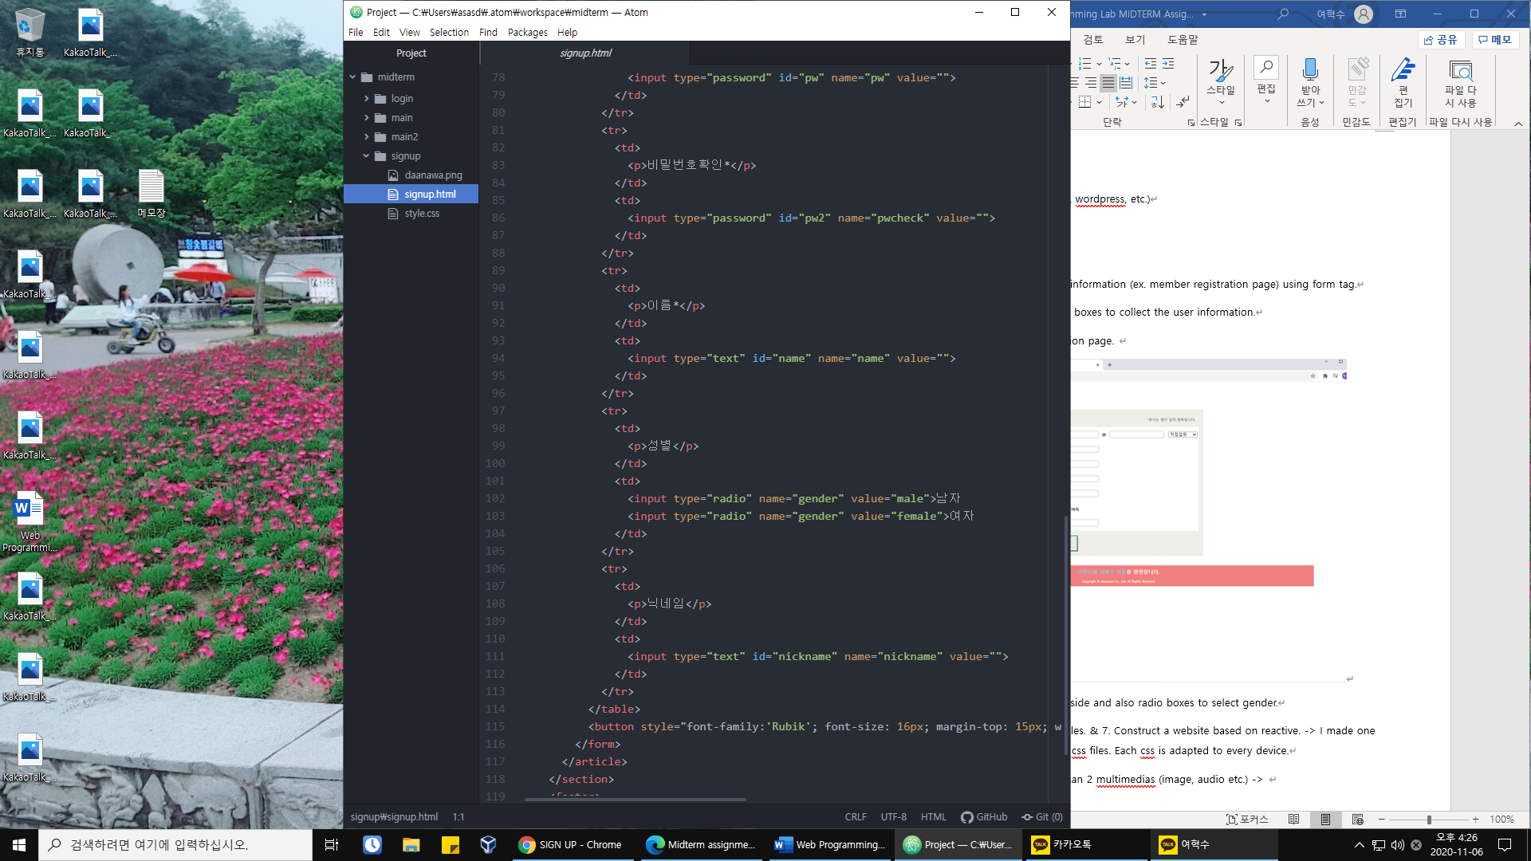

User information is contained in form tag which works on ‘get’ method.

6. Create more than 3 external css files. & 7. Construct a website based on reactive. -> I made one template per one html file by using css files. Each css is adapted to every device.

8. Hompage should include more than 2 multimedias (image, audio etc.) & 9. Use text-style to make it pretty. & 10. Use table tag.

Main.html

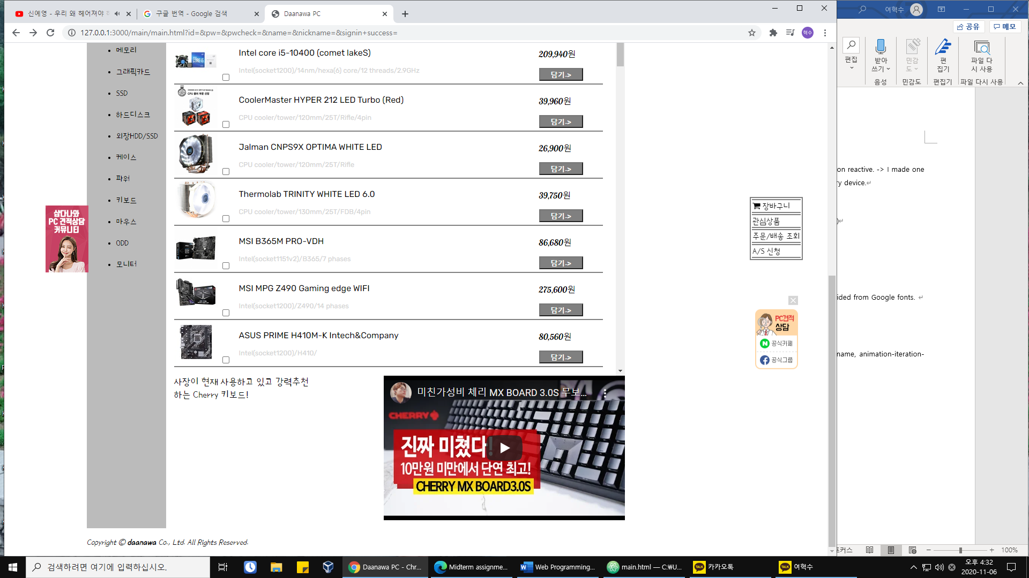

There are iframe multimedia and many images. Also footer text is italic and partially bold. So you can see some various text-style. Table is implemented to show information of pieces of computer in main.html .

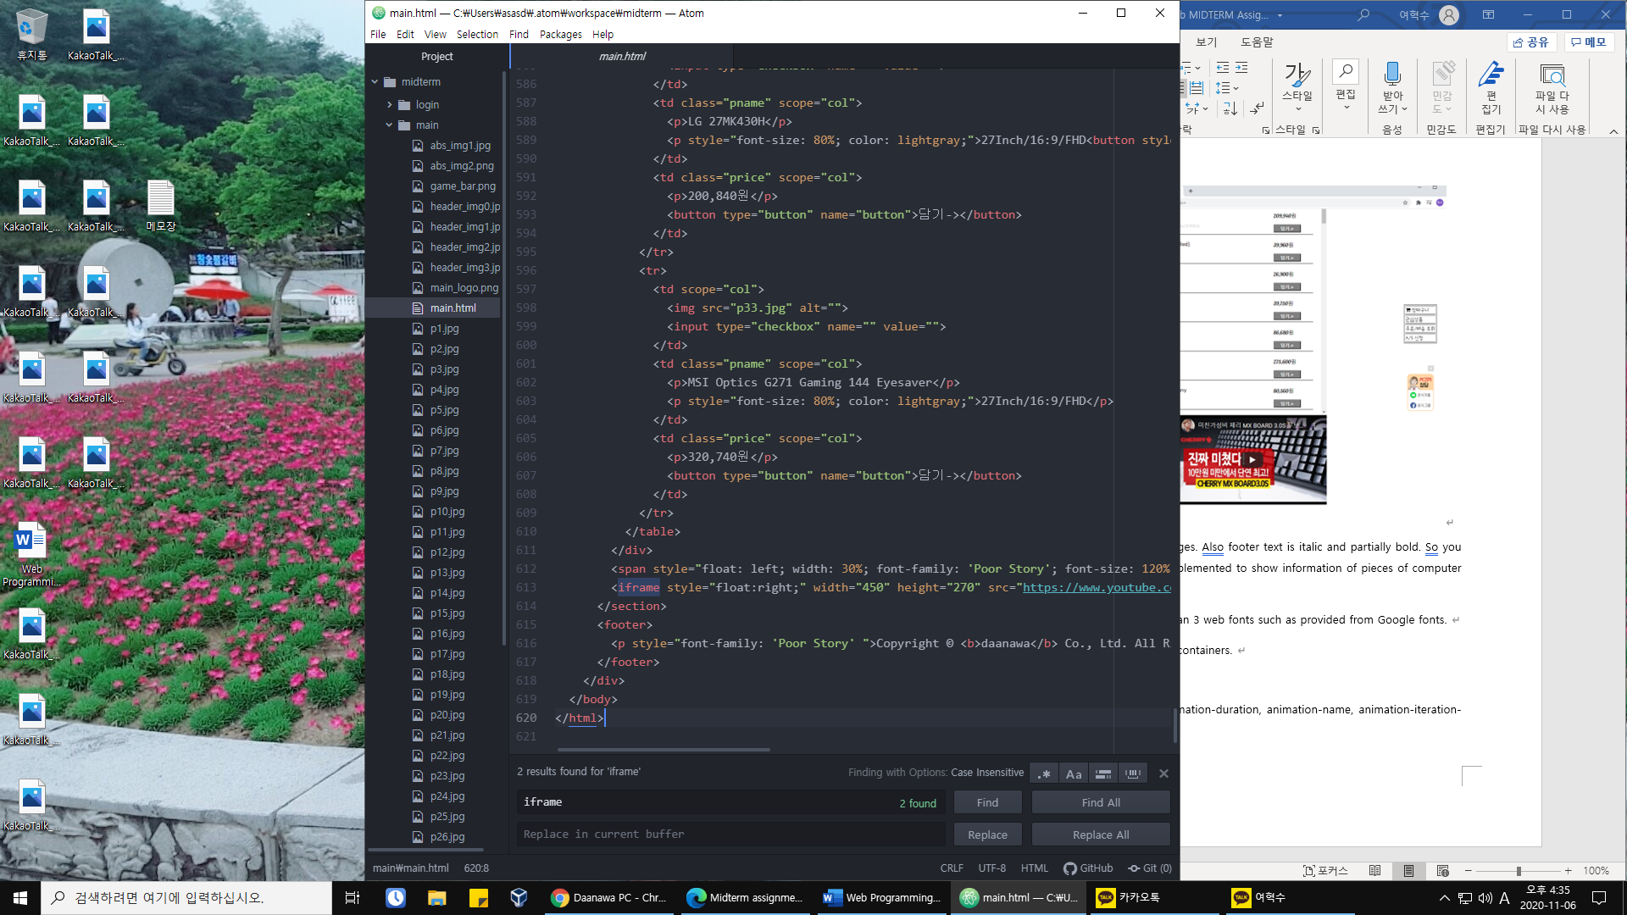

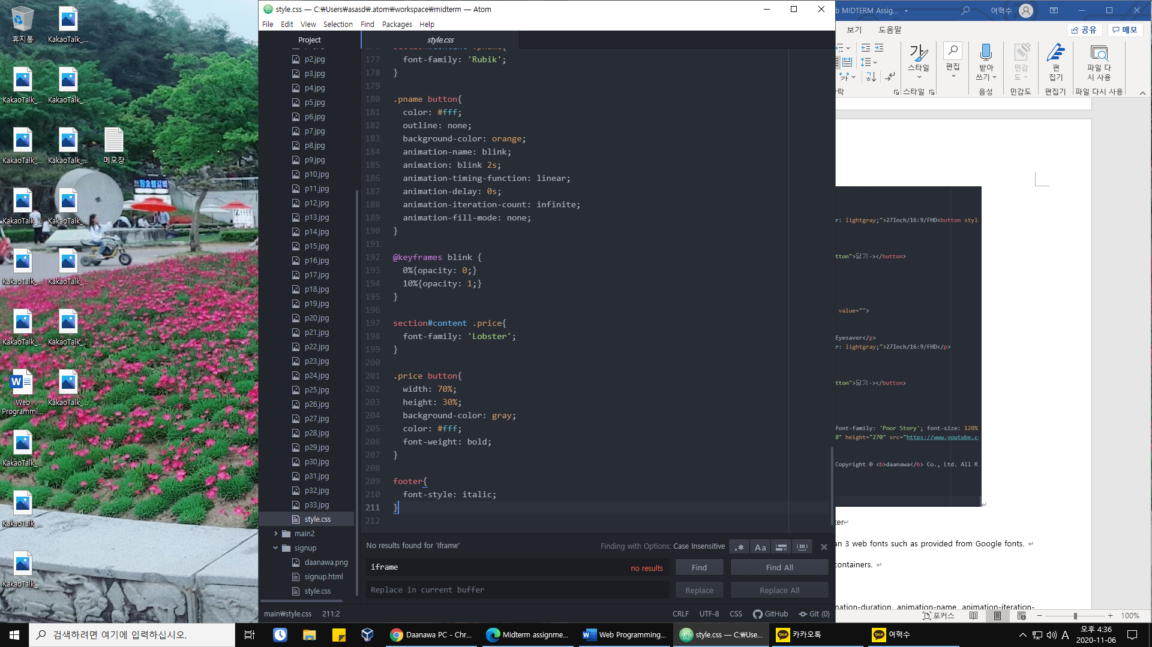

You can see codes of table, text-style of footer, and implementation of images and iframe.

11. Create effective pages by using more than 3 web fonts such as provided from Google fonts. 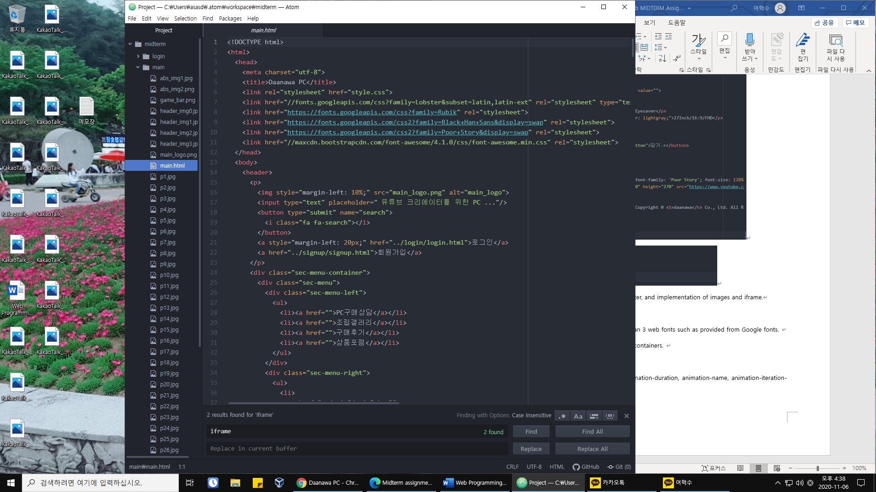

I use several google fonts by link tag. Ex) main.html

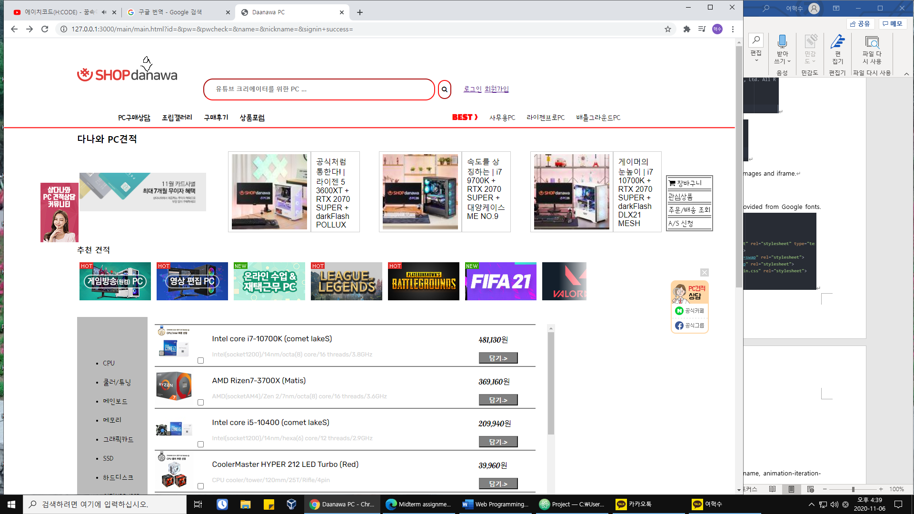

‘Poor Story’ ‘Rubik’ ‘Lobster’ ‘Black Han Sans’

12. Use the flex property to create flex box containers.

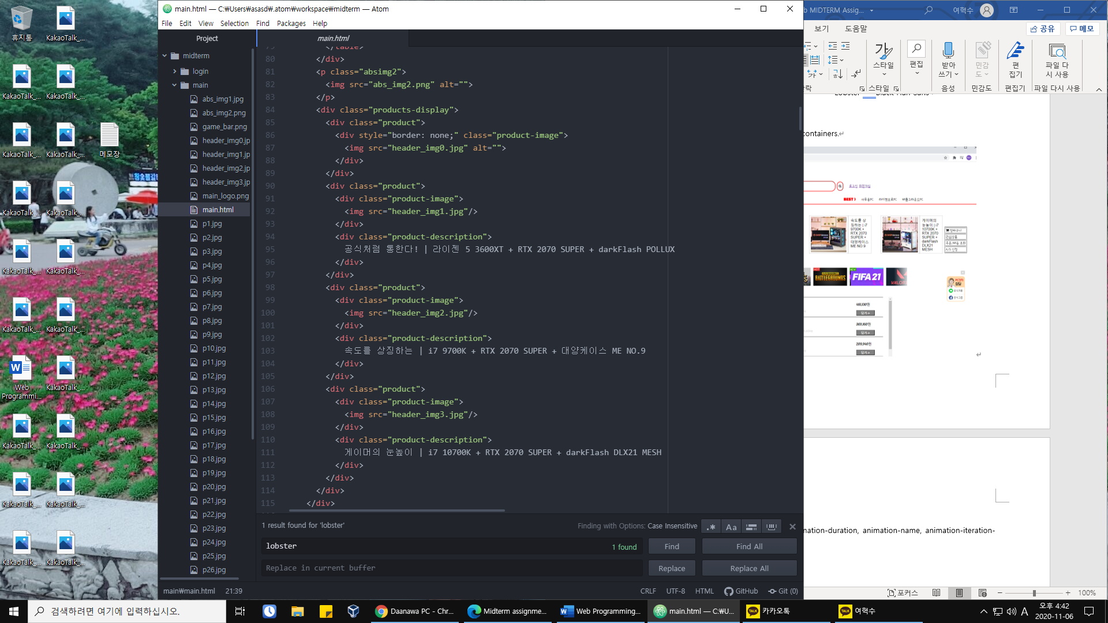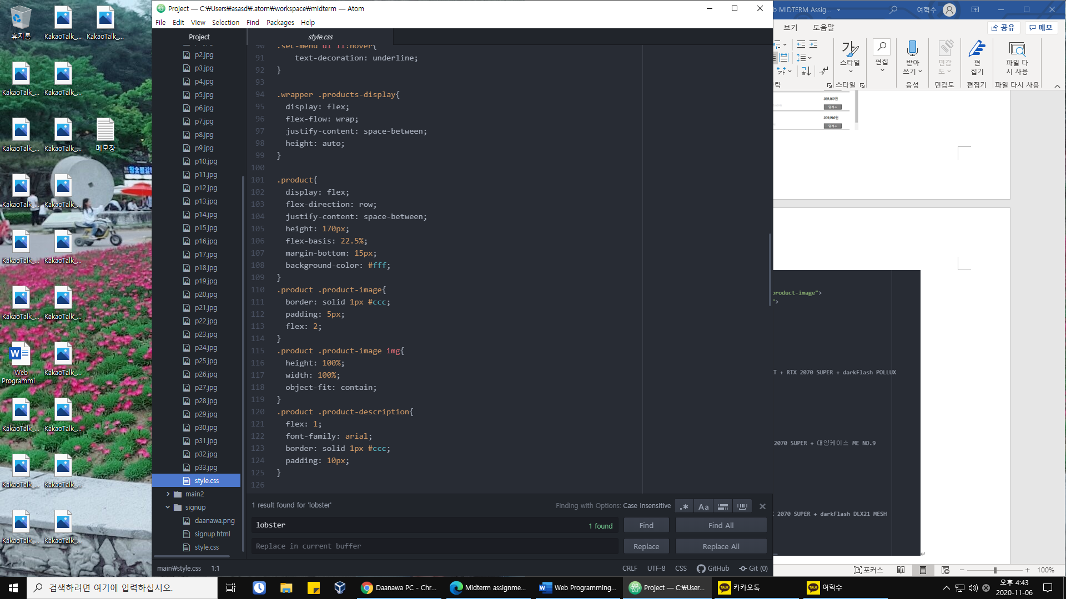

flex box container

Flex box container is implemented in <div class=”products-display”> with row direction. Width and height of each elements in container is manipulated with ‘flex’ value.

13. Use transform property. & 14. Use the @keyframes property and animation-duration, animation-name, animation-iteration-count for Animation.

I use transform property to implement bouncing img and blinking button.

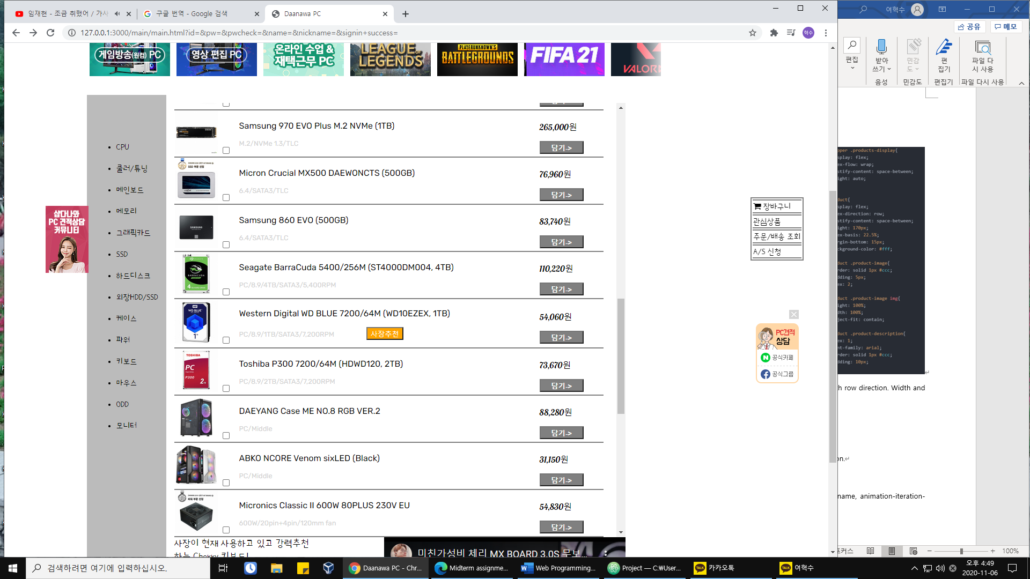

‘blink’ ‘bounce’

Example of bouncing img)

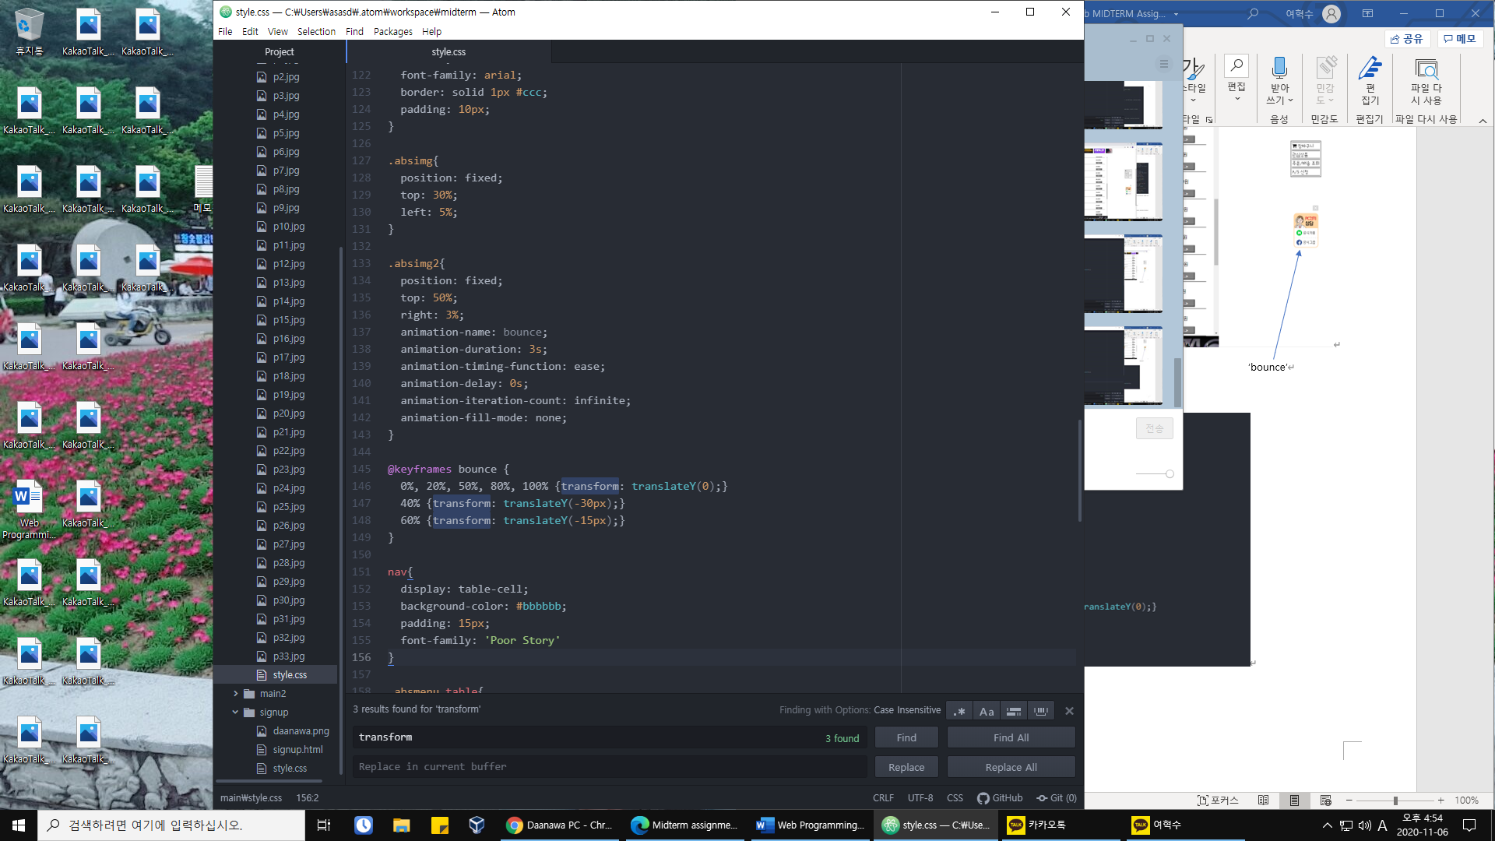use keyframes and some attributes.